**Classification Models – predicting quality**

**Naïve Bayes** model was run in Weka on using the dataset with 4,000 instances (split 70.0% train, remainder test) and 12 attributes (fixed acidity, volatile acidity, citric acid, residual sugar, chlorides, free sulfur dioxide, total sulfur dioxide, density, pH, sulphates, Quality and Alcohol content).

The accuracy of that model was only 45.4% (Fig 1.1).

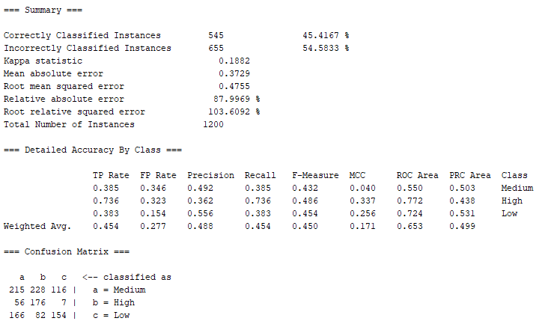 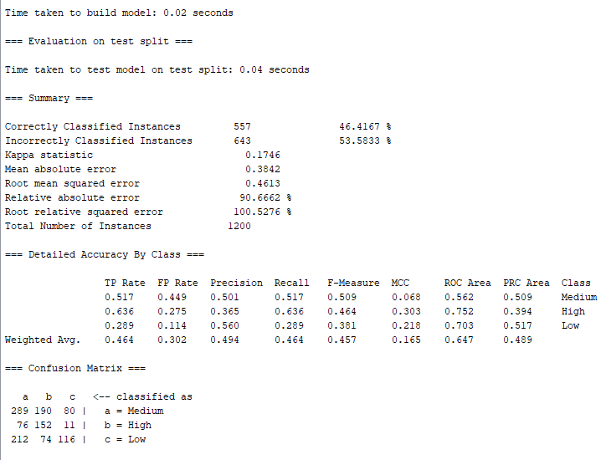

*Figure 1.1 Naïve Bayes classifier output (Weka)*

The same model was run after removing total sulfur dioxide attribute (correlated to free sulfur dioxide) and slight improvement in accuracy level was observed – 46.4%.

In the next step we used the correlation-based feature selection (CFS) algorithm in Weka to further eliminate the correlated redundant features from the dataset (Fig. 1.2).

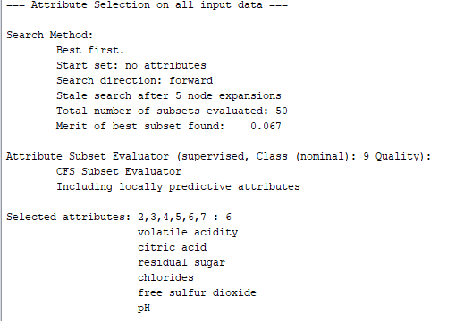

*Figure 1.2. Attributes selected by applying the CFS algorithm in Weka*

However, after executing the Naïve Bayes model in Weka using only attributes selected by CFS algorithm (volatile acidity, citric acid, residual sugar, chlorides, free sulfur dioxide, pH and Quality) we did not observe any major improvement in accuracy. The accuracy for this model was 45.5%.

|  |  |  |  |  |
| --- | --- | --- | --- | --- |
|  | **Class** | |  |  |
| **Attribute** | | **High** | **Medium** | **Low** |
|  | | 0.21 | 0.45 | 0.34 |
| **fixed acidity** | |  |  |  |
| mean | | 6.6968 | 6.8267 | 6.9602 |
| std. dev. | | 0.7846 | 0.8485 | 0.9121 |
| weight sum | | 834 | 1806 | 1360 |
| precision | | 0.1552 | 0.1552 | 0.1552 |
| **volatile acidity** | |  |  |  |
| mean | | 0.2689 | 0.2615 | 0.3121 |
| std. dev. | | 0.0946 | 0.0895 | 0.1167 |
| weight sum | | 834 | 1806 | 1360 |
| precision | | 0.0082 | 0.0082 | 0.0082 |
| **citric acid** | |  |  |  |
| mean | | 0.3306 | 0.3394 | 0.3329 |
| std. dev. | | 0.0828 | 0.1206 | 0.1436 |
| weight sum | | 834 | 1806 | 1360 |
| precision | | 0.0193 | 0.0193 | 0.0193 |
| **residual sugar** | |  |  |  |
| mean | | 4.6206 | 6.0033 | 6.6776 |
| std. dev. | | 3.7365 | 4.9864 | 5.1673 |
| weight sum | | 834 | 1806 | 1360 |
| precision | | 0.211 | 0.211 | 0.211 |
| **chlorides** | |  |  |  |
| mean | | 0.0374 | 0.0452 | 0.0522 |
| std. dev. | | 0.0108 | 0.0209 | 0.0288 |
| weight sum | | 834 | 1806 | 1360 |
| precision | | 0.0021 | 0.0021 | 0.0021 |
| **free sulfur dioxide** | | | | |
| mean | | 34.1524 | 35.313 | 34.7731 |
| std. dev. | | 14.2492 | 15.7009 | 20.5611 |
| weight sum | | 834 | 1806 | 1360 |
| precision | | 2.1908 | 2.1908 | 2.1908 |
| **pH** | |  |  |  |
| mean | | 3.2288 | 3.1951 | 3.1728 |
| std. dev. | | 0.1536 | 0.1512 | 0.147 |
| weight sum | | 834 | 1806 | 1360 |
| precision | | 0.0108 | 0.0108 | 0.0108 |
| **sulphates** | |  |  |  |
| mean | | 0.5 | 0.4921 | 0.4816 |
| std. dev. | | 0.1345 | 0.1118 | 0.1008 |
| weight sum | | 834 | 1806 | 1360 |
| precision | | 0.011 | 0.011 | 0.011 |
| **Alcohol content** | |  |  |  |
| High | | 300 | 564 | 473 |
| Medium | | 467 | 1008 | 777 |
| Low | | 70 | 237 | 113 |
| [total] | | 837 | 1809 | 1363 |

*Table 1.1 Naïve Bayes classifier model*

It would appear that the quality is decreasing with higher level of fixed acidity, residual sugar and chlorides and it is improved with higher pH level.

Decision Tree J48 model was executed in Weka using the dataset with 4,000 instances (split 70.0% train, remainder test) and 12 attributes (fixed acidity, volatile acidity, citric acid, residual sugar, chlorides, free sulfur dioxide, total sulfur dioxide, density, pH, sulphates, Quality and Alcohol content). The first Decision Tree model was executed with default settings in Weka (batch size 100, confidence factor 0.25, minimum number of instances per leaf 2). The accuracy of that model was 53.2%. The model was simplified by increasing the minimum number of instances per leaf to 28 and it improved its accuracy to 55.9%.

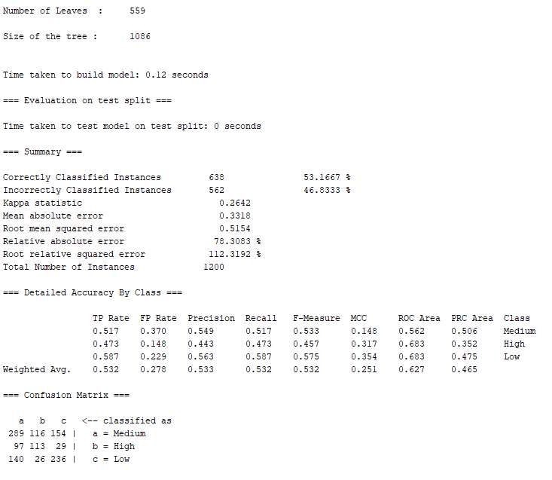 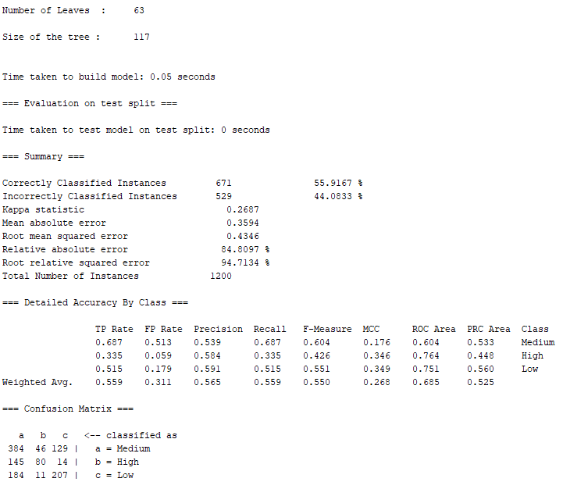

*Figure 1.3. Decision Tree J48 models’ comparison*

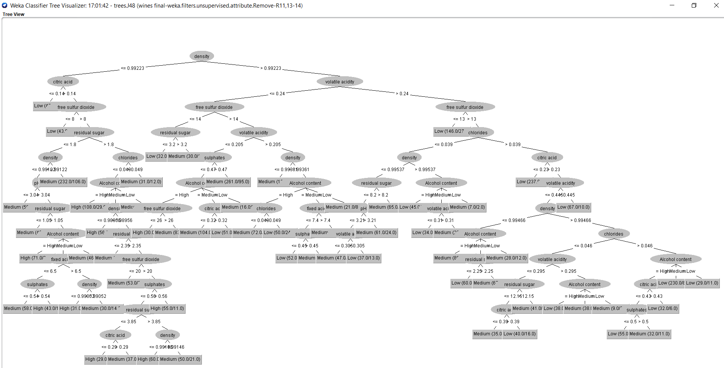

*Figure 1.4. Decision Tree J48 model in Weka*

We also tried Support Vector Machine model in Weka – SMO to predict quality attribute. The accuracy of that model was 57.8% (Fig. 1.5).

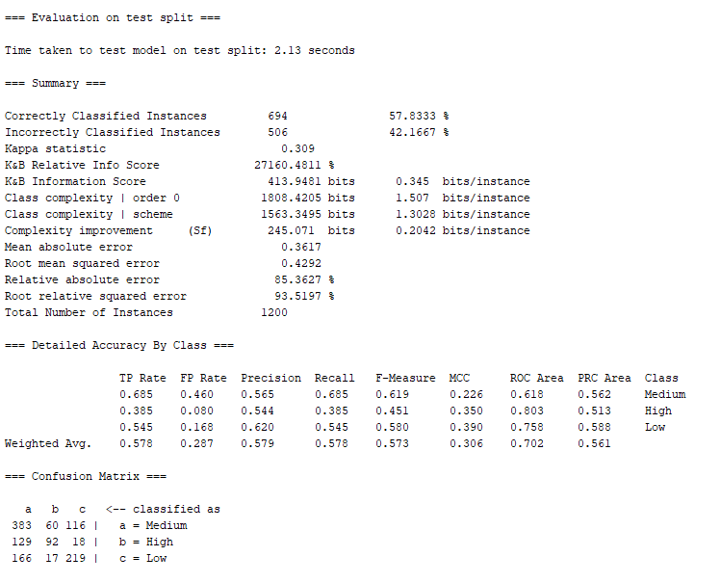

*Figure 1.5. SMO model Weka – evaluation output*

Support vector machine algorithm transforms training data into a higher dimension, where it searches for “decision boundary” (linear optimal separating hyperplane) that separates the data from one class from another. To find this hyperplane SVM model uses support vectors (“essential” training tuples) and margins (deﬁned by the support vectors).

The best accuracy level 67.4% (Fig. 1.6) was achieved using the Random Forest model using the dataset with 4,000 instances (split 70.0% train, remainder test) and 11 attributes (fixed acidity, volatile acidity, citric acid, residual sugar, chlorides, free sulfur dioxide, density, pH, sulphates, Quality and Alcohol content).

This is not surprising as Random Forest is an ensemble method where the decision is based on the outcome of a number (forest) of decision tree classifiers. The individual decision trees are generated using a random selection of attributes at each node to determine the split. During classiﬁcation, each tree votes and the most popular class is returned.

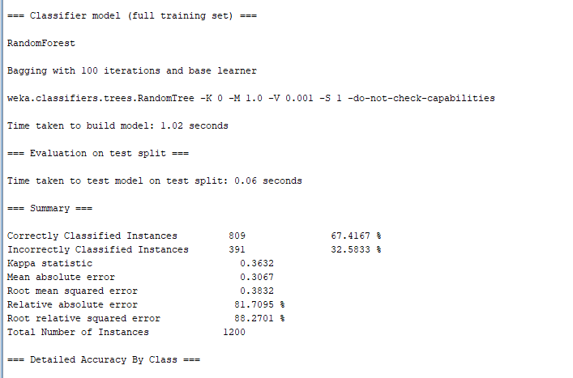

*Figure 1.6. Random Forest model in Weka*

**Classification Models – alcohol content**

We also used **Naïve Bayes and Decision Tree** models to review alcohol content. The original alcohol values were discretised: values lower than 9% were classed as low, 9 to 11% as medium and above 11% as high. After running the correlation-based feature selection (CFS) algorithm in Weka to we eliminated all attributes but fixed acidity, citric acid and density to classify alcohol content. The accuracy of the Naive Bayes model was 56.5% (Fig. 1.7).

The interesting insights learnt from these models:

* Alcohol content is higher in wines with higher fixed acidity levels and amount of citric acid and higher density.

Decision Tree (pruned J48) model was also executed using 12 attributes (fixed acidity, volatile acidity, citric acid, residual sugar, chlorides, free sulfur dioxide, total sulfur dioxide, density, pH, sulphates, Quality and Alcohol content) with minimum number of instances per leaf 28. The accuracy of that model was 61.7% (Fig. 1.8)

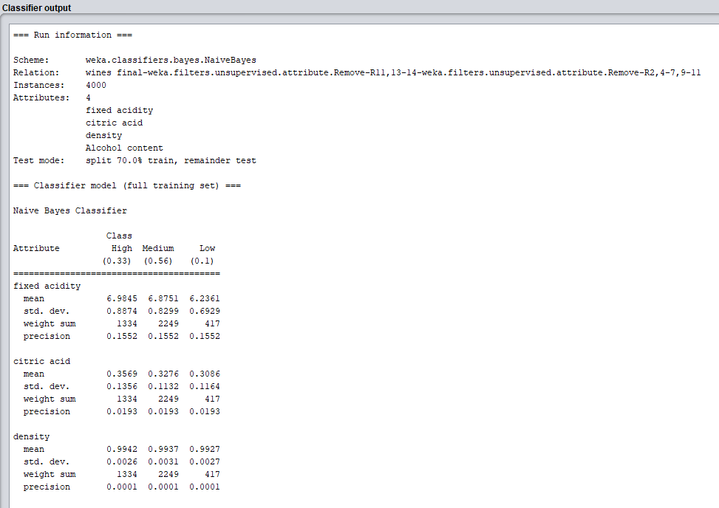

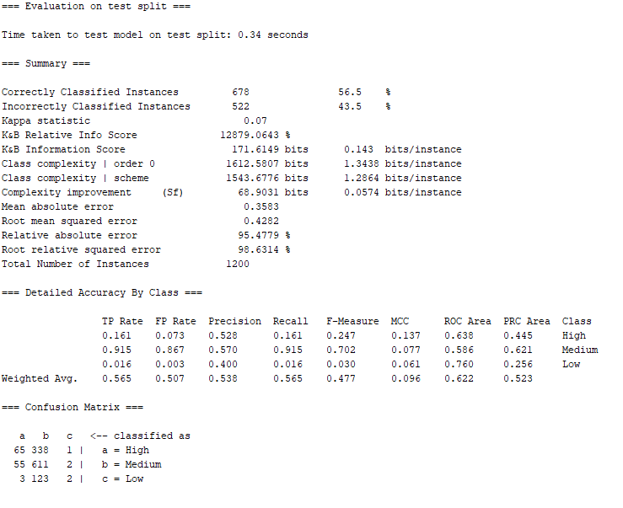

*Figure 1.7. Naïve Bayes model – alcohol content*

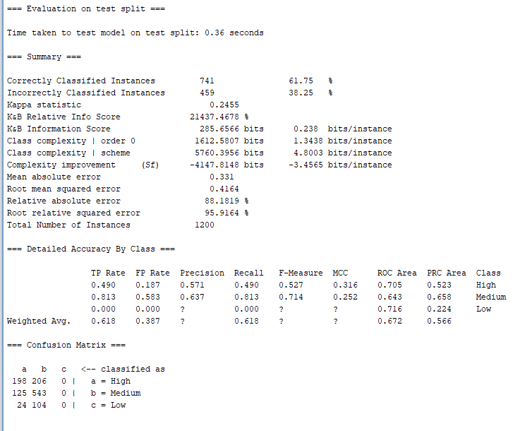

*Figure 1.8. Decision Tree J48 – alcohol content prediction – evaluation output Weka*

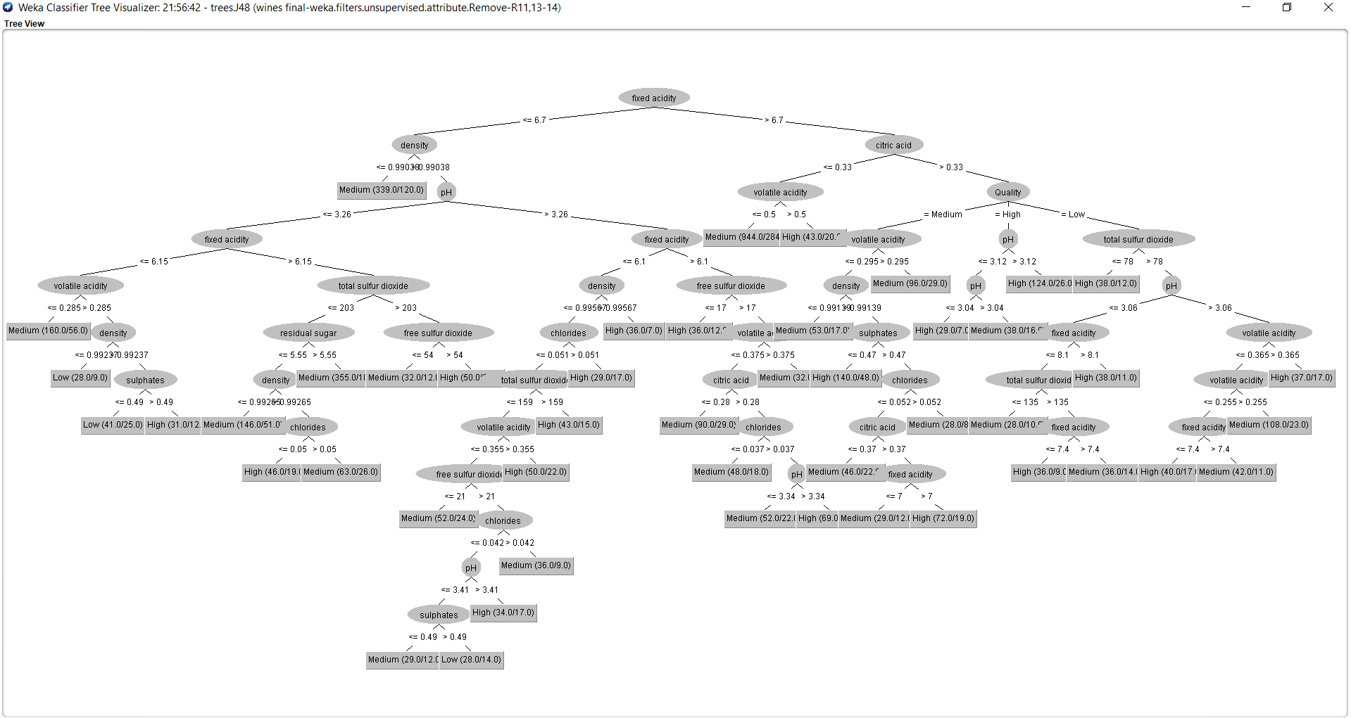

*Figure 1.9. Decision Tree J48 model – alcohol content prediction (Weka)*